Project Design Phase
Problem – Solution Fit

Date | 17 February 2026
Team ID | LTVIP2026TMIDS87366
Project Name | Prosperity Prognosticator: Machine Learning for Startup Success Prediction
Maximum Marks

Problem – Solution Fit :
The problem–solution fit ensures that the identified customer problem is properly addressed by the proposed system. In this project, investors and startup founders face difficulty in predicting whether a startup will succeed or fail before making important business decisions.
Many startups fail due to insufficient funding, lack of milestones, weak networking, or poor strategic planning. Currently, most startup decisions are based on intuition or limited information, which increases uncertainty and financial risk.
The proposed solution is a machine learning based startup success prediction system. The system analyzes historical startup data and predicts whether a startup is likely to be acquired or closed. It uses features such as funding details, milestones, relationships, and participation metrics to generate predictions along with a confidence score.
This solution fits the problem because it provides a data-driven decision support tool that reduces uncertainty, improves evaluation accuracy, and helps users make better investment or business decisions through a simple web interface.
Purpose:
- To reduce uncertainty in predicting startup success
- To provide a reliable data-driven decision support system
- To help investors and founders evaluate startup potential
- To generate quick predictions using a web-based application
- To demonstrate a complete machine learning solution from analysis to deployment

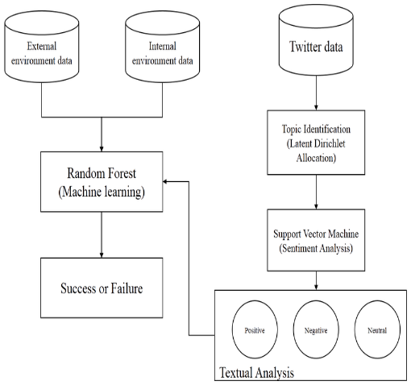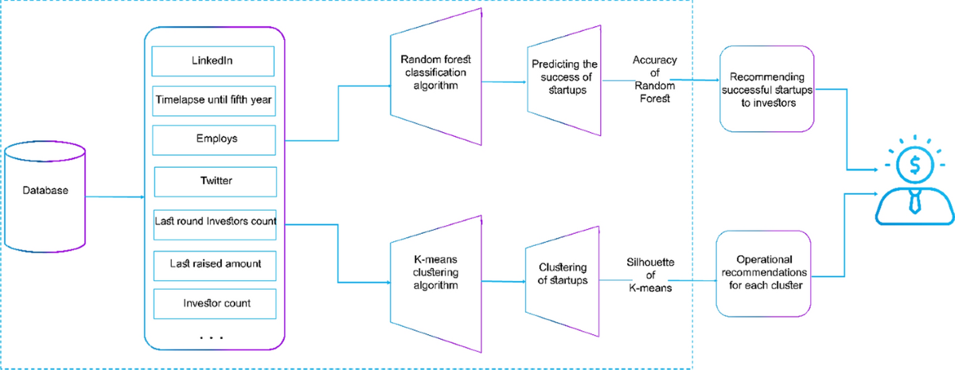
Figure: Problem–Solution Fit for Startup Success Prediction System

References:
- https://www.ideahackers.network/problem-solution-fit-canvas/
- https://medium.com/@epicantus/problem-solution-fit-canvas-aa3dd59cb4fe

